Exhibit L

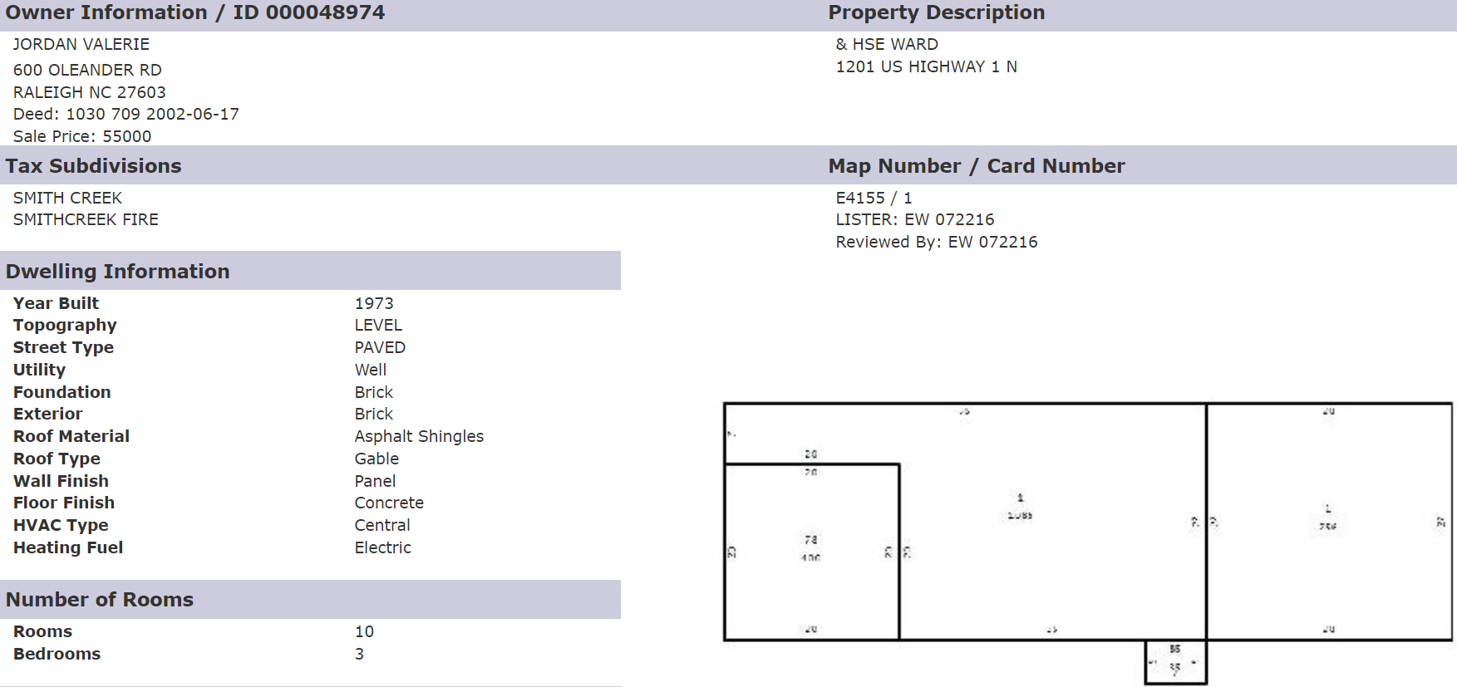
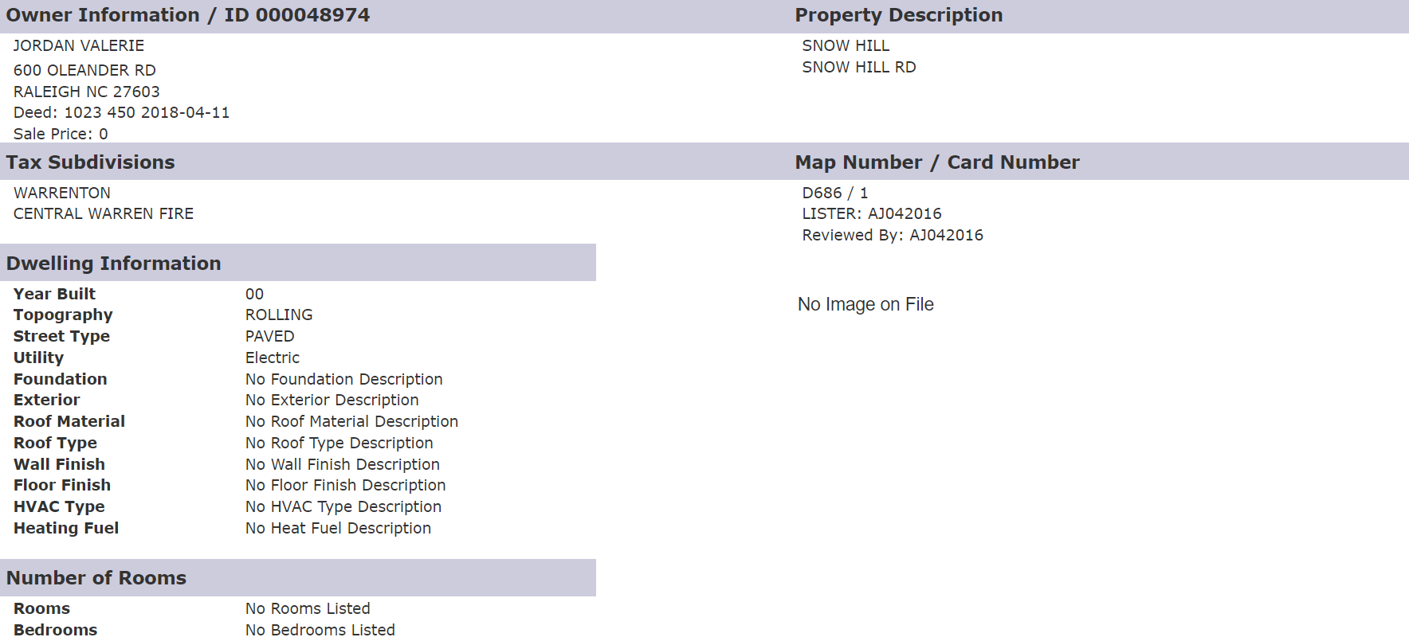

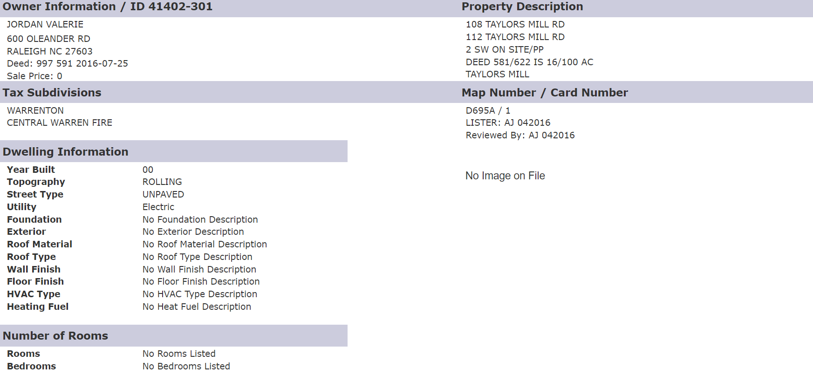
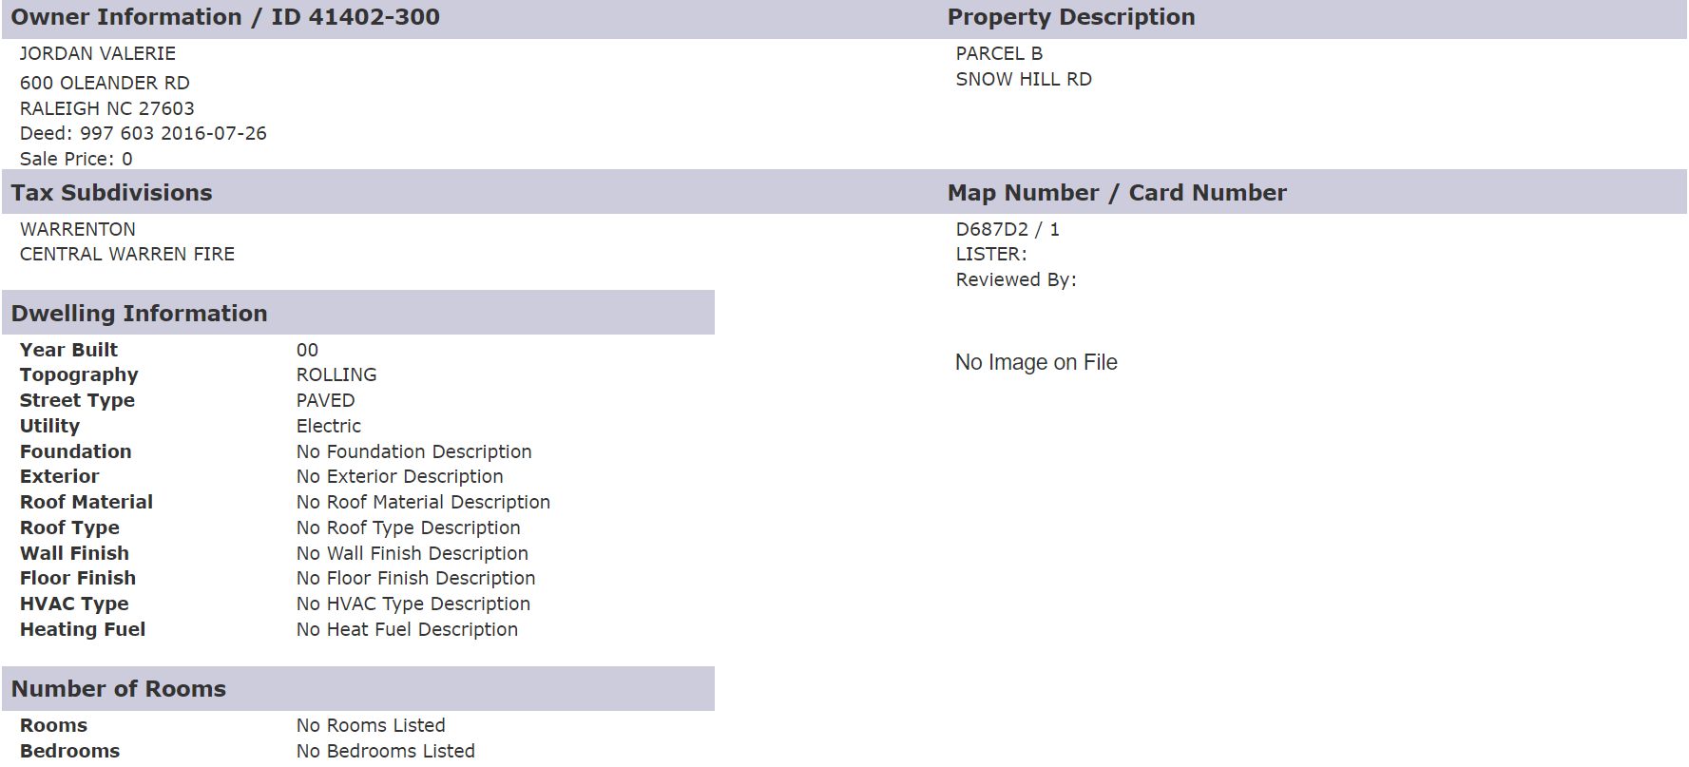

The Below Tax Bills Are the First Years That Jordan Paid Municipal Property Taxes on Each of The Properties. (Warren County Assessor, Accessed 6/23/22). Note the first years she paid taxes on these properties. She did not disclose ownership of these properties until her 2022 SEI.
- Jordan’s Property in Raleigh County Is Listed as The Mailing Address for Each of The Properties In Warren County. (Warren County Assessor, Accessed 6/23/22)
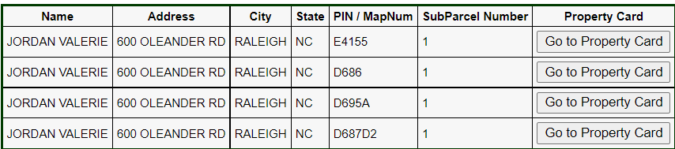

Parcel No. E4-155 2019 Property Tax Bill. (Warren County Assessor, Accessed 6/23/22)
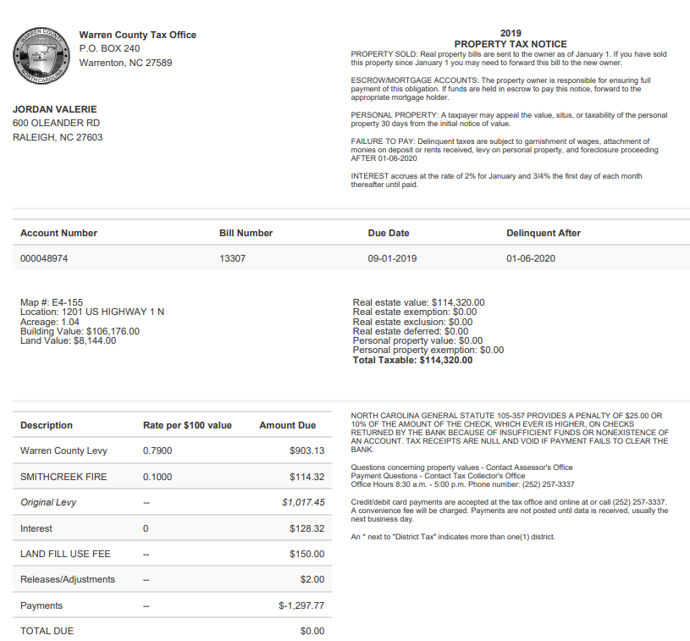
(Warren County Assessor, Accessed 6/23/22)

Parcel No. D6-86 2019 Property Tax Bill. (Warren County Assessor, Accessed 6/23/22)
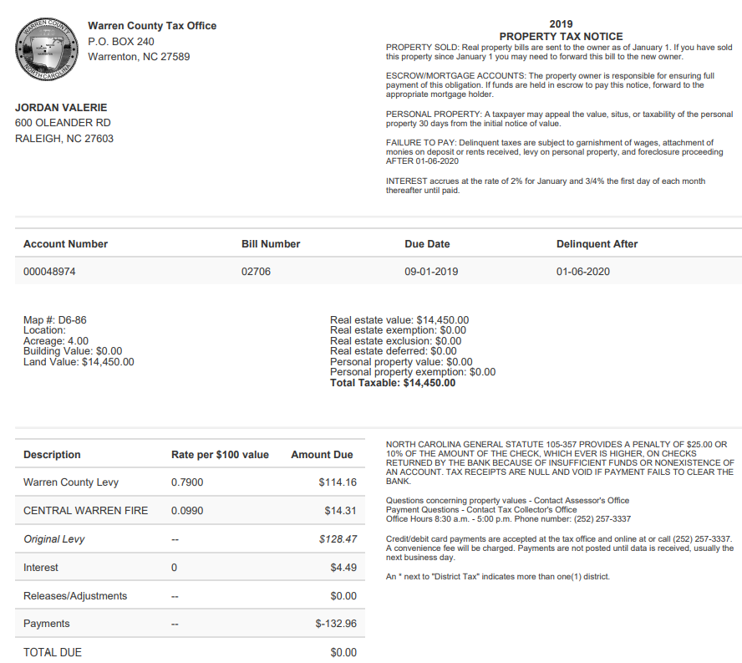
(Warren County Assessor, Accessed 6/23/22)

Parcel No. D6-95A 2017 Property Tax Bill. (Warren County Assessor, Accessed 6/23/22)
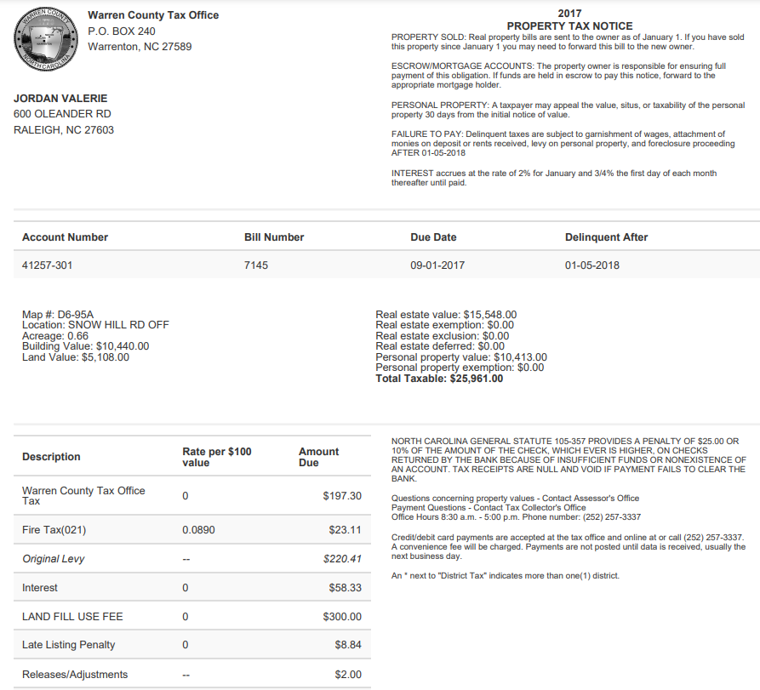
(Warren County Assessor, Accessed 6/23/22)

Parcel No. D6-87-D2 2019 Property Tax Bill. (Warren County Assessor, Accessed 6/23/22)
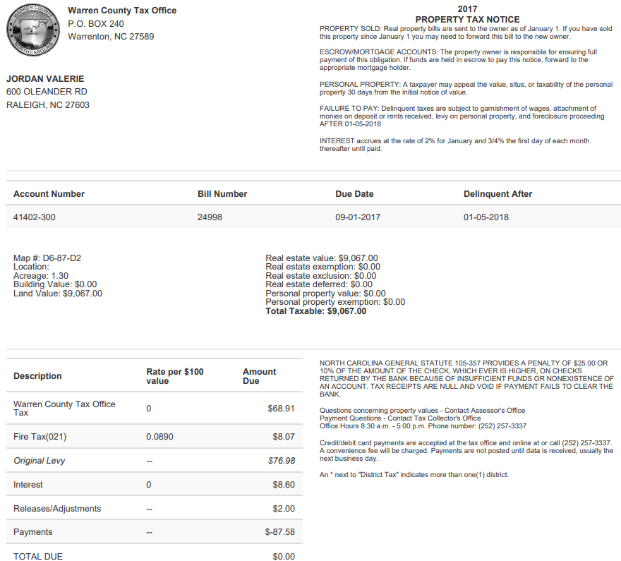
(Warren County Assessor, Accessed 6/23/22)

